***Course: 305-02: Mobile Application Development - 1***

***Unit-1: Concepts of Mobile computing.***

* 1. *Fundamentals of Mobile computing:*

***Introduction to Mobile Computing:***

*Mobile Computing refers a technology that allows transmission of* ***data, voice and video*** *via a computer or any other wireless enabled device. It is free from having a connection with a fixed physical link. It facilitates the users to move from one physical location to another during communication.*

*Mobile Computing is a technology that provides an environment that enables users to transmit data from one device to another device without the use of any physical link or cables.*

*In other words, you can say that mobile computing allows transmission of data, voice and video via a computer or any other wireless-enabled device without being connected to a fixed physical link. In this technology, data transmission is done wirelessly with the help of wireless devices such as mobiles, laptops etc.*

*This is only because of Mobile Computing technology that you can access and transmit data from any remote locations without being present there physically. Mobile computing technology provides a vast coverage diameter for communication. It is one of the fastest and most reliable sectors of the computing technology field.*

*The concept of Mobile Computing can be divided into three parts:*

1. *Mobile Communication*
2. *Mobile Hardware*
3. *Mobile Software*

***Mobile Communication:***

*Mobile Communication specifies a framework that is responsible for the working of mobile computing technology. In this case, mobile communication refers to an* ***infrastructure*** *that ensures seamless and reliable communication among wireless devices. This framework ensures the consistency and reliability of communication between wireless devices. The mobile communication framework consists of communication devices such as protocols, services, bandwidth, and portals necessary to facilitate and support the stated services. These devices are responsible for delivering a smooth communication process.*

*Mobile communication can be divided in the following four types:*

1. *Fixed and Wired*
2. *Fixed and Wireless*
3. *Mobile and Wired*
4. *Mobile and Wireless*

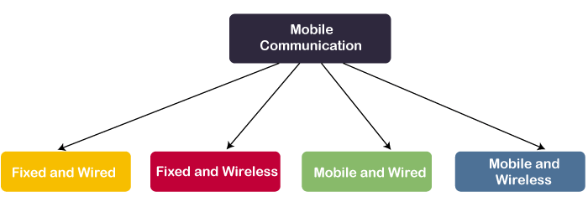

***Fixed and Wired:*** *In Fixed and Wired configuration, the devices are fixed at a position, and they are connected through a physical link to communicate with other devices.*

*For Example, Desktop Computer.*

***Fixed and Wireless:*** *In Fixed and Wireless configuration, the devices are fixed at a position, and they are connected through a wireless link to make communication with other devices.*

*For Example, Communication Towers, WiFi router*

***Mobile and Wired:*** *In Mobile and Wired configuration, some devices are wired, and some are mobile. They altogether make communication with other devices.*

*For Example, Laptops.*

***Mobile and Wireless:*** *In Mobile and Wireless configuration, the devices can communicate with each other irrespective of their position. They can also connect to any network without the use of any wired device.*

*For Example, WiFi Dongle.*

***Mobile Hardware***

*Mobile hardware consists of mobile devices or device components that can be used to receive or access the service of mobility. Examples of mobile hardware can be smartphones, laptops, portable PCs, tablet PCs, Personal Digital Assistants, etc.*

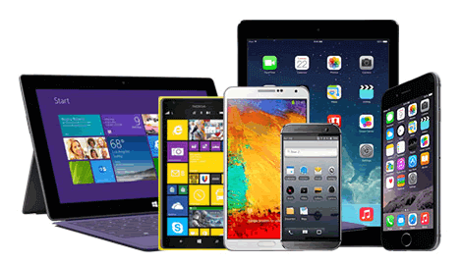

*These devices are inbuilt with a receptor medium that can send and receive signals. These devices are capable of operating in* ***full-duplex****. It means they can send and receive signals at the same time. They don't have to wait until one device has finished communicating for the other device to initiate communications.*

***Mobile Software***

*Mobile software is a program that runs on mobile hardware. This is designed to deal capably with the characteristics and requirements of mobile applications. This is the operating system for the appliance of mobile devices. In other words, you can say it the heart of the mobile systems. This is an essential component that operates the mobile device.*

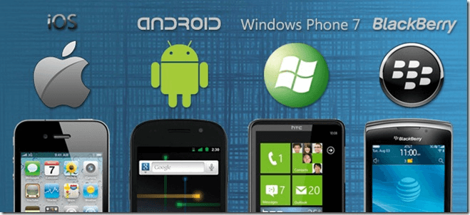

*This provides portability to mobile devices, which ensures wireless communication.*

***Applications of Mobile Computing:***

*Following is a list of some significant fields in which mobile computing is generally applied:*

* *Web or Internet access.*
* *Global Position System (GPS).*
* *Emergency services.*
* *Entertainment services.*
* *Educational services.*

***History and Evolution of Mobile Computing***

*The main idea of Mobile computing was evolving since the 1990s. It has evolved from two-way radios to modern day communication devices.*

*Devices used in Mobile Computing*

*Following is the list of most common forms of devices used in mobile computing:*

***1. Portable Computers***

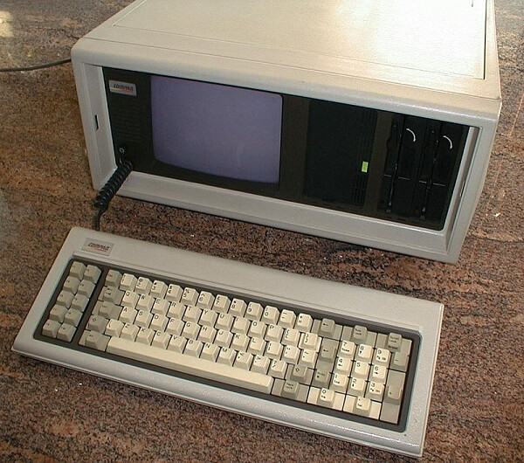*A portable computer is a computer that is designed in a way that you can move it from one place to another. It includes a display and a keyboard. Generally, portable computers are microcomputers.*

*Compaq Portable and Contemporary portable computer with 3 LCD screens were the early examples of portable computers. Now, portable computers are discontinued.*

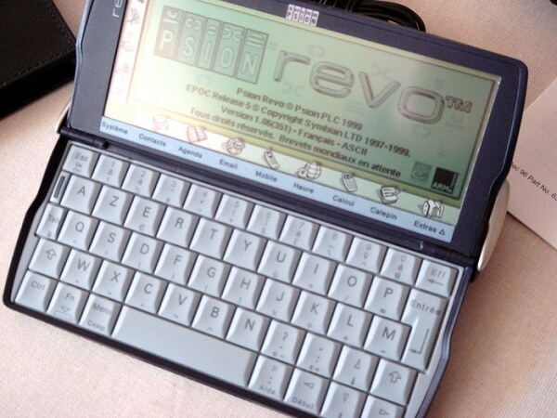***2. Personal Digital Assistant/Enterprise Digital Assistant (PDA or EDA)***

*A Personal Digital Assistant (PDA) is also known as a palmtop computer. Sometimes, it is also called Enterprise Digital Assistant (EDA). A personal Digital Assistant (PDA) is a mobile device used to function as a personal information manager or a personal data assistant. Its name, Personal Digital Assistant (PDA), was evolved from Personal Desktop Assistant, a software term for an application that prompts or prods the user of a computer with suggestions or provides a quick reference to contacts and other lists.*

*Apple Newton and UPOP PDA were the early examples of Personal Digital Assistant. Now, a Personal Digital Assistant (PDAs) are also discontinued.*

**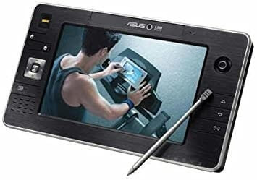*3. Ultra-Mobile PC***

*An ultra-mobile PC was a small form factor version of a pen computer. It was a class of laptops whose specifications were launched by Microsoft and Intel in 2006.*

*Samsung q1 ultra-premium was the early example of an ultra-mobile PC. Now, ultra-mobile PCs are also discontinued.*

***4. Laptop***

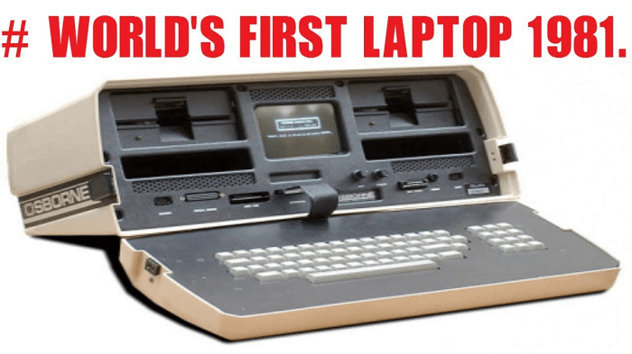*A laptop is a small, portable personal computer (PC) built in a foldable device. The folding structure of a laptop is called a clamshell form factor. The flip or clamshell is a form factor of a mobile phone or other devices that include two or more folded sections via a hinge. A laptop typically has a thin LCD or LED computer screen mounted on the inside of the clamshell's upper lid and an alphanumeric keyboard on the inside of the lower lid. Laptops are easy to carry for transportation, and that's why they are best suitable for mobile use.*

*Osborne 1 was the first laptop in the world. See the below picture.*

*You can now find the latest versions of laptops are so thin and efficient for any scientific work.*

***5. Smartphone***

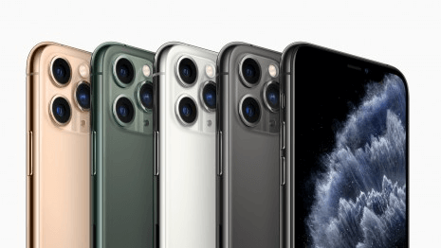*A smartphone is a mobile device that combines cellular and mobile computing functions into one unit. The smartphones are invented to provide more advanced computing capability and connectivity than basic feature phones.*

*Smartphones are different from basic feature phones by their more robust hardware capabilities and extensive mobile operating systems, which facilitate more comprehensive software, internet i.e., web browsing over mobile broadband, and multimedia functionality i.e., music, video, cameras, and gaming etc., along with the core phone functions such as voice calls and text messaging.*

*IBM Simon Personal Communicator thought to be the first smartphone in the world. Below is the image of IBM Simon Personal Communicator.*

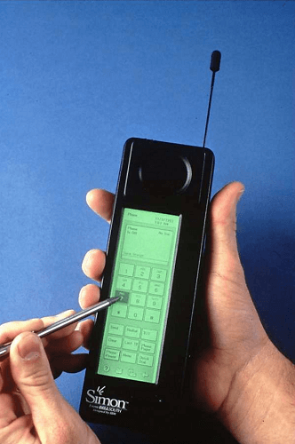

*Early smartphones were invented and marketed as attempting to bridge the functionality of standalone personal digital assistant (PDA) devices with support for cellular telephony but were limited by their bulky form, short battery life, slow, analog cellular networks, and the immaturity of wireless data services. But now, smartphones have the latest features of computers, more than one camera, advanced OS, bigger RAM and ROM. Now, they are also built with some artificial intelligence features such as unlock using facial recognition or fingerprint scanners, waterproof with IP67 and IP68 ratings and many other endless features.*

*Examples of new generation smartphone:*

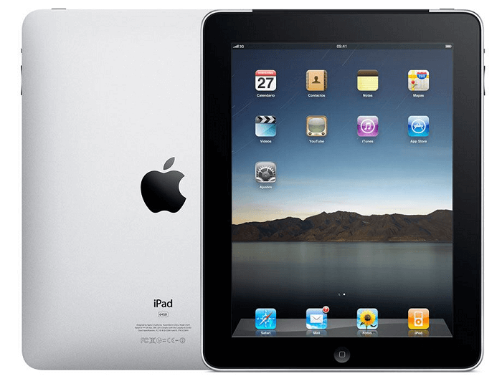***6. Tablet Computers***

*A tablet computer is generally known as a tablet. It is a mobile computer with a mobile operating system and a touch-screen display processing circuit, and a rechargeable battery in a single, thin and flat unit. Tablets can do what other personal computers can do, but they don't have some input/output (I/O) abilities that computers have. Nowadays, tablets are very much similar to modern smartphones. The only difference is that tablets are relatively larger than smartphones, with screens 7 inches or larger and may not support a cellular network.*

*First-generation Ipads and Sony Z2 Android were the early examples of tablets.*

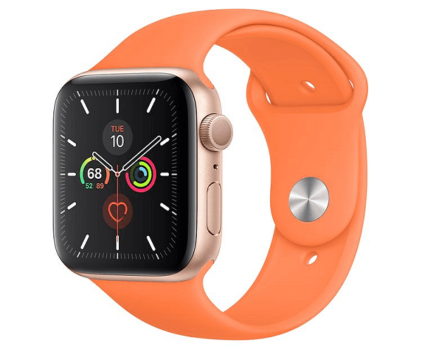***7. Wearable computers***

*Wearable computers are a type of computer that can be worn by the bearer under, with or on top of clothing. They are also known as body-borne computers or wearables, which are small electronic devices. Some examples of wearable computers are smartwatches, digital fitness bands etc.*

***8. E-reader***

*An e-reader is also called an e-book reader or e-book device. It is a mobile electronic device that is mainly designed to read digital e-books. A right e-reader provides great portability, readability, and battery life. The main advantages of e-readers over printed books are portability. A average e-reader can hold thousands of books while weighing less than one book. The best example of an E-reader is a Kindle.*

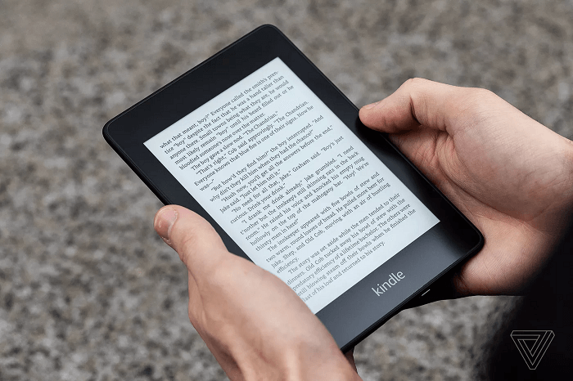

*1.1.1 Concepts of fixed and wireless network*

*Fixed vs. Wireless Networks in Mobile Computing*

*Fixed and Wireless Networks are both used in Mobile computing. Fixed networks commonly operate on radio transmission to connect established, wired communications systems. Let's see the differences between fixed and wireless networks in mobile computing.*

***Difference between Fixed and Wireless Networks***

*The differences between Fixed and Wireless networks can be distinguished as that the wireless networks do not require any cables to make a physical connection with the device. It is easily assessable because it is a shared medium. On the other hand, in the case of fixed networks, a physical configuration of devices is mandatory to perform data transmission. In this medium, you have to connect every new device separately and physically to the network. Let's consider and make a comparison between these two technologies used in mobile computing.*

*The following table specifies the main differences between the Fixed and Wireless Networks in mobile computing technology:*

|  |  |  |
| --- | --- | --- |
| *Sr. No* | *Wireless Networks* | *Fixed Networks* |
| *1* | *There is no requirement of any physical configuration in the wireless network.* | *In Fixed Networks, a physical configuration is required in any condition.* |
| *2* | *The data loss rate is high in Wireless Networks.* | *In Fixed Networks, a perfect link is established between the devices, so; the data loss rate is very low.* |
| *3* | *In Wireless Networks, the data transmission rate is comparatively low, so it provides less speed.* | *In Fixed Networks, the rate of data transmission is high, so it provides high speed.* |
| *4* | *Latency is high in Wireless Networks, which finally results in more delay.* | *There is no issue of latency in Fixed Networks because there is a perfect connection established between the devices that provide less delay.* |
| *5* | *The Wireless Networks may be hacked; that's why the security is always low in this type of network.* | *Fixed Networks connections are highly secured.* |

***Issues occurred in Mobile Computing.***

*There is a lot of advantage of using Mobile computing technology. It provides vast features from mobility to portability and from cloud to productivity. But, along with these advantages, you can face specific eye-catching issues while using mobile computing technology. Following is a list of issues we find while using fixed and wireless networks in mobile computing.*

*1.* ***Costly due to Wireless Medium***

*The Mobile computing technology mainly focuses on wireless infrastructure, so the cost of implementation is always high. It also faces issues like efficiency, delays and security, which we have to consider in project establishment.*

*2.* ***Issue due to Device Mobility***

*The device mobility is one of the most significant advantages of mobile computing technology. But, it is one of its major issues too. To obtain the device mobility feature of mobile computing technology, we have to install the highest standards' types of equipment. So, whenever the mobile device changes its environment, we have to restructure its configuration environment.*

*We have to configure the device mobility feature according to the location, environment and surroundings of a mobile device regularly.*

*3.* ***Security Issues in Mobile Computing***

*This is undoubtedly the biggest and one of the most discussed issues we face in mobile computing technology. It arises due to the shared medium ability of mobile computing.*

*The most significant security issues are:*

* *Physical Security or Data Security*
* *System Security or Network Security*

*These issues can be resolved by using some common tactics. These issues are:*

* *Using VPN technology*
* *Using Cryptography & Network Security in your project*
* *Use of Firewall technology in the project*

***Advantages and Disadvantages of Mobile Computing***

***Advantages of Mobile Computing Technology***

***Enhanced Productivity***

*We can use mobile devices in various companies, which can reduce the time and cost for clients and themselves and enhance the productivity of the company.*

***Location Flexibility***

*This technology facilitates users to work efficiently and effectively from whichever location they want to do their tasks. So, a user can work without being in a fixed position. This facility makes them able to carry out numerous tasks at the same time and also benefitted the company.*

***Saves Time***

*The location flexibility facility of mobile computing makes it time-saving. It cuts down the time consumed or wasted while traveling from different locations or to the office and back. It facilitates users to access all the essential documents and files over a secure channel and work on their computers. It has also reduced many unnecessary incurred expenses.*

***Support Cloud Computing***

*By using mobile Computing technology, you can save your documents on an online server and access them anytime and anywhere when you have an internet connection. You can access these files on several mobiles simultaneously.*

***Entertainment***

*Nowadays, mobile devices can be used as an entertainment source. They provide a lot of entertainment facilities to their users.*

*Besides the above advantages, it provides some other facilities such as Device Mobility, Simple Framework, easy and simple infrastructure etc.*

***Disadvantages of Mobile Computing Technology***

*Along with these advantages, there are some disadvantages also of mobile computing technology. Following is the list of biggest disadvantages:*

***Poor Quality of Connectivity***

*This is one of the biggest disadvantages because if you are not near any of these connection providers, your access to the internet may be minimal.*

***Security Issues***

*Mobile VPNs are not very safe to connect, and there is always a chance of security concerns.*

***High on Power Consumption***

*These devices run on batteries that do not tend to long-lasting. So, if in a situation where there is no source of power for charging, then that will be a failure.*

*Besides the above, there are also some disadvantages such as low data transmission rates, High data losses, Frequent network issues etc.*

*1.1.2 Introduction of Multiplexing, Modulation*

***Multiplexing in Mobile Computing***

*Multiplexing is a technique used in the area of electronics and signal processing. In mobile computing, telecommunications and computer networks, Multiplexing is a method that can be used to combine multiple* ***analog*** *or* ***digital*** *signals into one signal over a shared medium. The main aim of using this method is to share a scarce resource.*

*Example: You can see a real-life example of Multiplexing in the telecommunication field where several telephone calls may be carried using one wire. Multiplexing is also called as* ***muxing****.*

***History of Multiplexing***

*The concept of Multiplexing was originated in telegraphy in the 1870s. Nowadays, it is widely used in communications.*

*George Owen Squier is called the father of Multiplexing in telephony. He was credited for the development of telephone carrier multiplexing in 1910.*

***Key points of Multiplexing***

*Multiplexing is a technique that allows multiple simultaneous analogs or digital signal transmission across a single data link.*

*The main motive behind the development of Multiplexing is to provide simple and easy communication, proper resource sharing and its utilization. This is the best way to utilize and share a limited resource equally among multiple devices.*

*Multiplexing can be classified into the following four types:*

1. *Frequency Division Multiplexing (FDM)*
2. *Time Division Multiplexing (TDM)*
3. *Code Division Multiplexing (CDM)*
4. *Space Division Multiplexing (SDM)*
5. ***Frequency Division Multiplexing (FDM)***

*Frequency division multiplexing or FDM is inherently an analog technology. As the name specifies, in Frequency Division Multiplexing, the frequency dimension spectrum is split into smaller frequency bands. It combines several smaller distinct frequency ranges signals into one medium and sends them over a single medium. In FDM, the signals are electrical signals.*

*FDM's most common applications are a traditional radio or television broadcasting, mobile or satellite stations, or cable television.*

*For example: In cable TV, you can see that only one cable is reached to the customer's locality, but the service provider can send multiple television channels or signals simultaneously over that cable to all customers without any interference. The customers have to tune to the appropriate frequency (channel) to access the required signal.*

*In FDM, several frequency bands can work simultaneously without any time constraint.*

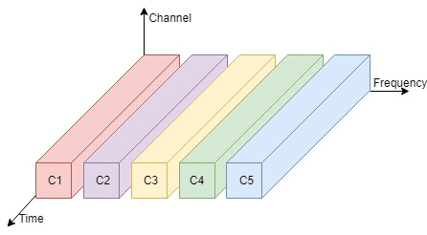

***Advantages of FDM***

*The concept of frequency division multiplexing (FDM) applies to both analog signals and digital signals.*

*It facilitates you to send multiple signals simultaneously within a single connection.*

***Disadvantages of FDM***

*It is less flexible.*

*In FDM, the bandwidth wastage may be high.*

***Usage***

*It is used in Radio and television broadcasting stations, Cable TV etc.*

1. ***Time Division Multiplexing (TDM)***

*The Time Division Multiplexing or (TDM) is a digital or analog technology (in rare cases) that uses time, instead of space or frequency, to separate the different data streams. It is used for a specific amount of time in which the whole spectrum is used.*

*The Time frames of the same intervals are divided so that you can access the entire frequency spectrum at that time frame.*

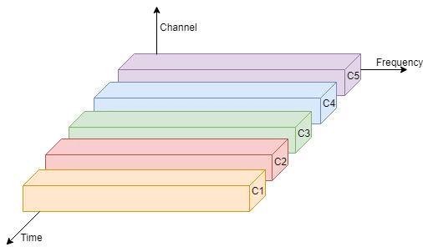

***Advantages of TDM***

*It facilitates a single user at a time.*

*It is less complicated and has a more flexible architecture.*

***Disadvantages of TDM***

*It isn't easy to implement.*

*Usage*

*It is mainly used in telephonic services.*

1. ***Code Division Multiplexing (CDM)***

*The Code Division Multiplexing or (CDM) allots a unique code to every channel so that each of these channels can use the same spectrum simultaneously at the same time.*

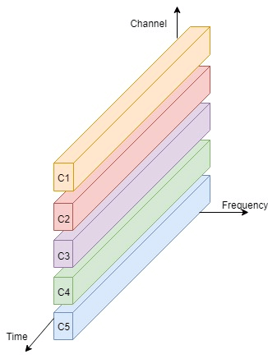

*Advantages of CDM*

*It is highly efficient.*

*It faces fewer Inferences.*

*Disadvantages of CDM*

*The data transmission rate is low.*

*It is complex.*

*Usage*

*It is mainly used in Cell Phone Spectrum Technology (2G, 3G etc.).*

1. ***Space Division Multiplexing (SDM)***

*The Space Division Multiplexing or (SDM) is called a combination of Frequency Division Multiplexing (FDM) and Time Division Multiplexing (TDM).*

*It passes messages or data-parallel with the use of specific frequency at a specific. It means a particular channel will be used against a specific frequency band for some amount of time.*

*Advantages of SDM*

*In SDM, the data transmission rate is high.*

*It uses Time and Frequency bands at its maximum potential.*

*Disadvantages of SDM*

*An inference may occur.*

*It faces high inference losses.*

*Usage*

*It is used in GSM (Global Service for Mobile) Technology.*

***Modulation in Mobile Computing***

*Modulation is a process of mixing signals with a sinusoid to produce a new form of signals. The newly produced signal has certain benefits over an un-modulated signal. Mixing of low-frequency signal with a high-frequency carrier signal is called Modulation.*

*In other words, you can say that "Modulation is the process of converting one form of signals into another form of signals." For example, Analog signals to Digital signals or Digital signals to Analog signals.*

*Modulation is also called signal modulation.*

*Example: Let's understand the concept of signal modulation by a simple example. Suppose an Analog transmission medium is available to transmit signals, but you have a digital signal that needs to be transmitted through this Analog medium. So, to complete this task, you have to convert the digital signal into an analog signal. This process of conversion of signals from one form to another form is called Modulation.*

***Need for Modulation/ Why Use Modulation?***

*The baseband or low-frequency signals are not such strong and compatible signals that can be used for direct transmission. To make these signals travel longer distances, we have to increase their strength by modulating them with a high-frequency carrier wave. This process doesn't affect the parameters of the modulating signal.*

*Modulation is used to make the message carrying signal strong to be transmitted over a long distance and establish a reliable communication. A high-frequency signal can travel up to a longer distance without getting affected by external disturbances. In Modulation, these high-frequency signals are used as a carrier signal to transmit the message signal. This process is called Modulation. In Modulation, the carrier signals' parameters are changed according to the instantaneous values of the modulating signal.*

*Another reason to modulate a signal is to allow a smaller antenna as we know that a low-frequency signal would need a huge antenna. An antenna needs to be about 1/10th the length of the wavelength of the signal to be efficient. Modulation converts the low-frequency signal into a much higher frequency signal, which has much smaller wavelengths and allows a smaller antenna.*

***Advantages of Modulation***

*Following is the list of some advantages of implementing Modulation in the communication systems:*

* *By implementing Modulation, the antenna size gets reduced. Before modulation technology, the antenna used for transmission had to be very large. The range of communication gets limited as the wave cannot travel to a distance without getting modulated.*
* *The range of communication has increased.*
* *The reception quality is immensely improved.*
* *Receivers are allowed to adjust to the bandwidth.*
* *Multiplexing of signals occurs.*
* *No signal mixing occurs.*

***Types of Modulation***

*Primarily Modulation can be classified into two types:*

1. *Digital Modulation*
2. *Analog Modulation*

***Digital Modulation***

*Digital Modulation is a technique in which digital signals/data can be converted into analog signals. For example, Base band signals.*

*Digital Modulation can further be classified into four types:*

1. *Amplitude Shift Key(ASK) Modulation*
2. *Minimum Shift Key (MSK) Modulation*
3. *Frequency Shift Key (FSK) Modulation*
4. *Phase Shift Key (PSK) Modulation*

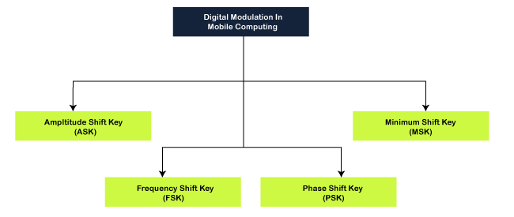

*Amplitude Shift Key (ASK) Modulation*

*As the name suggests, in Amplitude Shift Key or ASKS Modulation, the amplitude is represented by "1," and if the amplitude does not exist, it is represented by "0".*

*Using Amplitude Shift Key Modulation is very simple, and it requires a very low bandwidth.*

*Amplitude Shift Key Modulation is vulnerable to inference or deduction.*

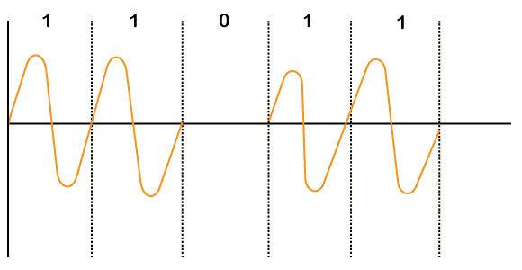

*Minimum Shift Key (MSK) Modulation*

* *The Minimum Shift Key or MSK Modulation is the most effective technique of Modulation and can be implemented for almost every stream of bits. It is easy and effective than Amplitude Shift Key, Frequency Shift Key and Phase Shift Key.*
* *MSK is mostly used because of its ability and flexibility to handle "One(1)" and "Zero(0)" transition of binary bits.*

*Frequency Shift Key (FSK) Modulation*

* *In Frequency Shift Key or FSK Modulation, different notations f1 and f2 are used for different frequencies.*
* *Here, f1 is used to represent bit "1," and f2 represents bit "0".*
* *It is also a simple modulation technique but uses different frequencies for different bits; bandwidth requirement becomes high.*

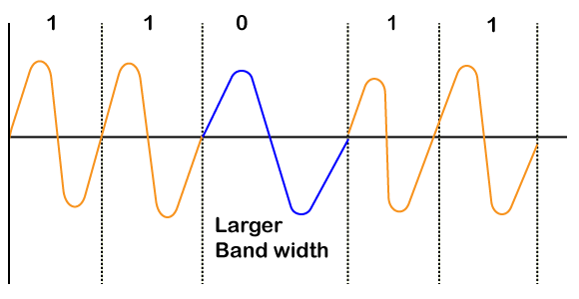

*Phase Shift Key (PSK) Modulation*

*In Phase Shift Key or PSK Modulation, the phase difference is used to differentiate between the "1" and "0" bits.*

*If the bit is "1", a simple wave is drawn, and if the bit becomes "0", the phase of the wave is shifted by "180 or π".*

*PSK Modulation is more complicated than ASK and FSK Modulation, but it is robust too.*

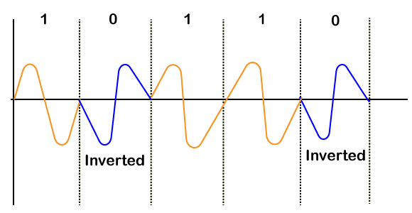

***Analog Modulation in Mobile Computing***

*Analog modulation is a process of transferring analog low-frequency baseband signal such as an audio or TV signal over a higher frequency carrier signal such as a radio frequency band. Baseband signals are always analog to this modulation.*

*In other words, you can say that "Analog Modulation is a technique which is used in analog data signals transmission into digital signals."*

*An example of Analog Modulation is Broadband Signals.*

*There are three properties of a carrier signal in analog modulation i.e., amplitude, frequency and phase. So, the analog modulation can further be classified as:*

1. *Amplitude Modulation (AM)*
2. *Frequency Modulation (FM)*
3. *Phase Modulation (PM)*

*Difference between Digital and Analog Modulation*

*Both digital and analog modulation are used to vary or transform signals from one for to another, but the difference is that an analog-modulated signal is demodulated into an analog baseband waveform. On the other hand, in digital modulation, a digitally modulated signal contains discrete modulation units, called symbols, that are interpreted as digital data.*

***Amplitude Modulation***

*Amplitude modulation or AM is a modulation technique that is used in electronic communication. It is most commonly used for transmitting messages with a radio carrier wave. It varies the instantaneous amplitude of the carrier signal or waves according to the message signal's instantaneous amplitude.*

*If we denote the message signal as m(t) and c(t)= Acoswct, then amplitude modulation signal F(t) will be written as:*

F(t)= Acoswct+m(t) coswct

F(t)=[A+m(t)] coswct

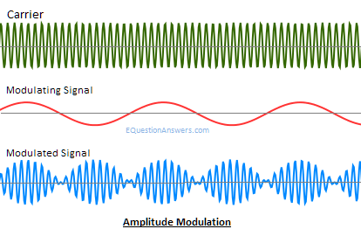

*History of Amplitude modulation*

*Amplitude modulation was the earliest modulation technique used for transmitting audio in radio broadcasting. It was developed during the first quarter of the 20th century and was based on the Roberto Landell De Moura and Reginald Fessenden's radiotelephone experiments proposed in 1900.*

*Advantages of Amplitude Modulation*

*Amplitude Modulation is easy to implement. It is the simplest type of modulation.*

*Amplitude Modulation, we can easily do Demodulation by using few components and a circuit.*

*The hardware design of both the transmitter and receiver is very simple, that's why it is cost-effective.*

*The receiver used for Amplitude Modulation is very cheap.*

*Disadvantages of Amplitude Modulation*

*Amplitude Modulation is not a very power efficient technique.*

*Amplitude Modulation requires a very high bandwidth that is equivalent to that of the highest audio frequency.*

*Amplitude Modulation is very susceptible to noise. You can easily notice the noise.*

*Usage of Amplitude Modulation*

*Amplitude Modulation is used in AM radio communication. AM radio broadcast is an example of Amplitude Modulation.*

***Frequency Modulation***

*Frequency Modulation or FM is the process of encoding the information in a carrier wave by varying the instantaneous frequency of the wave. It varies the instantaneous frequency of the carrier signal according to the instantaneous amplitude of the message signal.*

*If we denote the message signal as m(t) and c(t)= Acoswct, then Frequency modulation signal F(t) will be written as:*

F(t)= Acos(wc t+kf ∫m(α)dα)

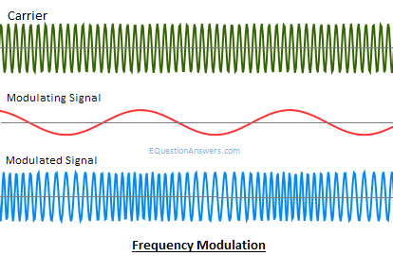

*Advantages of Frequency Modulation*

*Frequency Modulation is widely used for FM radio broadcasting.*

*It is also used in telemetry, sound synthesis, seismic prospecting, radar, and monitoring newborns for seizures via EEG, two-way radio systems, magnetic tape-recording systems and some video-transmission systems.*

*The main advantage of using frequency modulation in radio transmission is that it has a larger signal-to-noise ratio. That's why it rejects radio frequency interference better than an equal power amplitude modulation (AM) signal. This is the main reason why most music radio channels prefer to broadcast over FM radio.*

*In FM, Modulation and Demodulation do not receive any channel noise.*

*Disadvantages of Frequency Modulation*

*FM consists of a complicated circuit than AM for modulation and Demodulation.*

*Usage of Frequency Modulation*

*The main example of Frequency Modulation is FM radio broadcasting.*

***Phase modulation (PM)***

*Phase modulation or PM is the technique of varying the carrier signal's instantaneous phase according to the instantaneous amplitude of the message signal. It encodes the message signal as changes occurred in the instantaneous phase of a carrier signal.*

*If we denote the message signal as m(t) and c(t)= Acoswct, then Phase modulation signal F(t) will be written as:*

F(t)= Acos(wct+kpm(t))

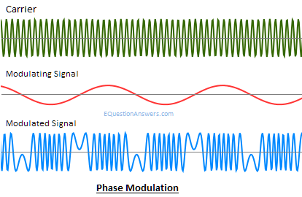

*Advantages of Phase modulation*

*Phase Modulation is mainly used for transmitting radio waves. It is also used in many digital transmission coding schemes and technologies such as Wi-Fi, GSM and satellite television.*

*In PM, Modulation and Demodulation do not receive any channel noise.*

*Disadvantages of Phase modulation*

*The PM modulation and Demodulation consists of a complicated circuit than AM and FM.*

*Usage of Phase modulation*

*Phase Modulation is mainly used in Wi-Fi, GSM and satellite television.*

*1.1.3 Fundamentals of spectrum, Bluetooth technology*

***Spread Spectrum in Mobile Computing***

*Spread spectrum is a technique used for wireless communications in telecommunication and radio communication. In this technique, the frequency of the transmitted signal, i.e., an electrical signal, electromagnetic signal, or acoustic signal, is deliberately varied and generates a much greater bandwidth than the signal would have if its frequency were not varied.*

*In other words, "Spread Spectrum is a technique in which the transmitted signals of specific frequencies are varied slightly to obtain greater bandwidth as compared to initial bandwidth."*

*Now, spread spectrum technology is widely used in radio signals transmission because it can easily reduce noise and other signal issues.*

***Example of Spread Spectrum***

*Let's see an example to understand the concept of spread spectrum in wireless communication:*

*We know that a conventional wireless signal frequency is usually specified in* ***megahertz (MHz) or gigahertz (GHz).*** *It does not change with time (Sometimes it is exceptionally changed in the form of small, rapid fluctuations that generally occur due to modulation). Suppose you want to listen to FM stereo at frequency 104.8 MHz on your radio, and then once you set the frequency, the signal stays at 104.8 MHz. It does not go up to 105.1 MHz or down to 101.1 MHz. You see that your set digits on the radio's frequency dial stay the same at all times. The frequency of a conventional wireless signal is kept as constant to keep bandwidth within certain limits, and the signal can be easily located by someone who wants to retrieve the information.*

***In this conventional wireless communication model, you can face at least two problems:***

1. *A signal whose frequency is constant is subject to catastrophic interference. This interference occurs when another signal is transmitted on or near the frequency of a specified signal.*
2. *A constant-frequency signal can easily be intercepted. So, it is not suitable for the applications in which information must be kept confidential between the source (transmitting party) and the receiver.*

*The spread spectrum model is used to overcome with this conventional communication model. Here, the transmitted signal frequency is deliberately varied over a comparatively large segment of the electromagnetic radiation spectrum. This variation is done according to a specific but complicated mathematical function. If the receiver wants to intercept the signal, it must be tuned to frequencies that vary precisely according to this function.*

***Reasons to use Spread Spectrum***

* *Spread spectrum signals are distributed over a wide range of frequencies and then collected and received back to the receiver. On the other hand, wide-band signals are noise-like and challenging to detect.*
* *Initially, the spread spectrum was adopted in military applications because of its resistance to jamming and difficulty intercepting.*
* *Now, this is also used in commercial wireless communication.*
* *It is most preferred because of its useful bandwidth utilization ability.*

***Usage of Spread Spectrum***

*There are many reasons to use this spread spectrum technique for wireless communications. The following are some reasons:*

* *It can successfully establish a secure medium of communication.*
* *It can increase the resistance to natural interference, such as noise and jamming, to prevent detection.*
* *It can limit the power flux density (e.g., in satellite down links).*
* *It can enable multiple-access communications.*

***Types of Spread Spectrum***

*Spread Spectrum can be categorized into two types:*

* *Frequency Hopping Spread Spectrum (FHSS)*
* *Direct Sequence Spread Spectrum(DSSS)*

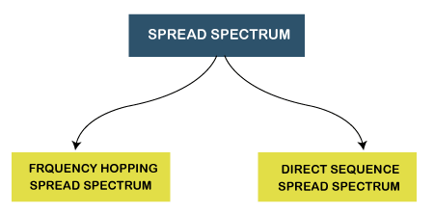

1. ***Frequency Hopping Spread Spectrum (FHSS)***

*The Frequency Hopping Spread Spectrum or FHSS allows us to utilize bandwidth properly and maximum. In this technique, the whole available bandwidth is divided into many channels and spread between channels, arranged continuously.*

*The frequency slots are selected randomly, and frequency signals are transmitted according to their occupancy.*

*The transmitters and receivers keep on hopping on channels available for a particular amount of time in milliseconds.*

*So, you can see that it implements the frequency division multiplexing and time-division multiplexing simultaneously in FHSS.*

*The Frequency Hopping Spread Spectrum or FHSS can also be classified into two types:*

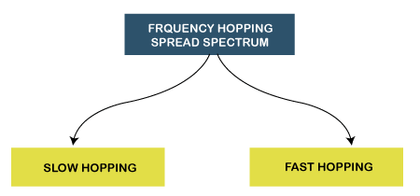

***Slow Hopping****: In slow hopping, multiple bits are transmitted on a specific frequency or same frequency.*

***Fast Hopping****: In fast hopping, individual bits are split and then transmitted on different frequencies.*

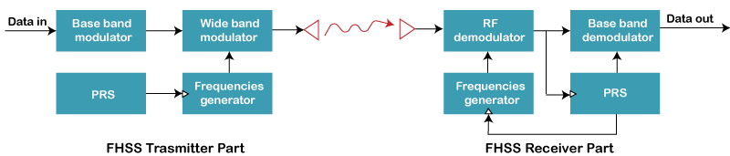

***Advantages of Frequency Hopping Spread Spectrum (FHSS)***

*The following are some advantages of frequency hopping spread spectrum (FHSS):*

* *The biggest advantage of Frequency Hopping Spread Spectrum or FHSS is its high efficiency.*
* *The Frequency Hopping Spread Spectrum or FHSS signals are highly resistant to narrowband interference because the signal hops to a different frequency band.*
* *It requires a shorter time for acquisition.*
* *It is highly secure. Its signals are very difficult to intercept if the frequency-hopping pattern is not known; that's why it is preferred to use in Military services.*
* *We can easily program it to avoid some portions of the spectrum.*
* *Frequency Hopping Spread Spectrum or FHSS transmissions can share a frequency band with many types of conventional transmissions with minimal mutual interference. FHSS signals add minimal interference to narrowband communications, and vice versa.*
* *It provides a very large bandwidth.*
* *It can be simply implemented as compared to DsSS.*

***Disadvantages of Frequency Hopping Spread Spectrum (FHSS)***

*The following are some disadvantages of Frequency Hopping Spread Spectrum (FHSS):*

* *FHSS is less Robust, so sometimes it requires error correction.*
* *FHSS needs complex frequency synthesizers.*
* *FHSS supports a lower data rate of 3 Mbps as compared to the 11 Mbps data rate supported by DSSS.*
* *It is not very useful for range and range rate measurements.*
* *It supports the lower coverage range due to the high SNR requirement at the receiver.*
* *Nowadays, it is not very popular due to the emerging of new wireless technologies in wireless products.*

***Applications of Frequency Hopping Spread Spectrum (FHSS)***

*Following is the list of most used applications of Frequency Hopping Spread Spectrum or FHSS:*

* *The Frequency Hopping Spread Spectrum or FHSS is used in wireless local area networks (WLAN) standard for Wi-Fi.*
* *FHSS is also used in the wireless personal area networks (WPAN) standard for Bluetooth.*

1. ***Direct Sequence Spread Spectrum (DSSS)***

*The Direct Sequence Spread Spectrum (DSSS) is a spread-spectrum modulation technique primarily used to reduce overall signal interference in telecommunication. The Direct Sequence Spread Spectrum modulation makes the transmitted signal wider in bandwidth than the information bandwidth. In DSSS, the message bits are modulated by a bit sequencing process known as a spreading sequence. This spreading-sequence bit is known as a chip. It has a much shorter duration (larger bandwidth) than the original message bits. Following are the features of Direct Sequence Spread Spectrum or DSSS.*

* *In Direct Sequence Spread Spectrum or DSSS technique, the data that needs to be transmitted is split into smaller blocks.*
* *After that, each data block is attached with a high data rate bit sequence and is transmitted from the sender end to*
* *the receiver end.*
* *Data blocks are recombined again to generate the original data at the receiver's end, which was sent by the sender, with the help of the data rate bit sequence.*
* *If somehow data is lost, then data blocks can also be recovered with those data rate bits.*
* *The main advantage of splitting the data into smaller blocks is that it reduces the noise and unintentional inference.*

*The Direct Sequence Spread Spectrum or DSSS can also be classified into two types:*

* *Wide Band Spread Spectrum*
* *Narrow Band Spread Spectrum*

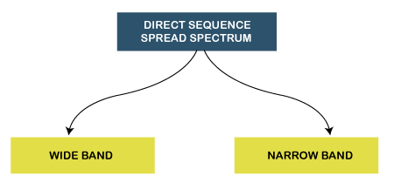

***Advantages of Direct Sequence Spread Spectrum (DSSS)***

*The following are some advantages of Direct Sequence Spread Spectrum or DSSS:*

*Direct Sequence Spread Spectrum or DSSS is less reluctant to noise; that's why the DSSS system's performance in the presence of noise is better than the FHSS system.*

* *In Direct Sequence Spread Spectrum or DSSS, signals are challenging to detect.*
* *It provides the best discrimination against multipath signals.*
* *In Direct Sequence Spread Spectrum, there are very few chances of jamming because it avoids intentional interference such as jamming effectively.*

***Disadvantages of Direct Sequence Spread Spectrum (DSSS)***

*The following are some disadvantages of Direct Sequence Spread Spectrum or DSSS:*

* *The Direct Sequence Spread Spectrum or DSSS system takes large acquisition time; that's why its performance is slow.*
* *It requires wide-band channels with small phase distortion.*
* *In DSSS, the pseudo-noise generator generates a sequence at high rates.*

***Applications of Direct Sequence Spread Spectrum (DSSS)***

*Following is the list of most used applications of Direct Sequence Spread Spectrum or DSSS:*

* *Direct Sequence Spread Spectrum or DSSS is used in LAN technology.*
* *Direct Sequence Spread Spectrum or DSSS is also used in Satellite communication technology.*
* *DSSS is used in the military and many other commercial applications.*
* *It is used in the low probability of the intercept signal.*
* *It supports Code division multiple access.*

***Bluetooth Technology in Mobile Computing*** 

*Bluetooth technology is a high speed and low powered wireless technology designed to connect phones or other portable equipment for communication or file transmissions. This is based on mobile computing technology. Following is a list of some prominent features of Bluetooth technology:*

* *Bluetooth is also known as IEEE 802.15 standard or specification that uses low power radio communications to link phones, computers and other network devices over a short distance without using any type of connecting wires.*
* *As Bluetooth is an open wireless technology standard so, it is used to send or receive data to connected devices present across a certain distance using a band of 2.4 to 2.485 GHz.*
* *In Bluetooth technology, the wireless signals transmit data and files over a short distance, typically up to 30 feet or 10 meters.*
* *Bluetooth technology was developed by a group of 5 companies known as Special Interest Group formed in 1998. The companies are Ericsson, Intel, Nokia, IBM, and Toshiba.*
* *The range of Bluetooth technology for data exchange was up to 10 meters in older versions of devices, but the latest version of Bluetooth technology i.e., Bluetooth 5.0, can exchange data in the range of about 40-400 meters.*
* *The average speed of data transmission in Bluetooth technology was around 1 Mbps in the very first version. The second version was 2.0+ EDR, which provided the data rate speed of 3Mbps. The third was 3.0+HS, which provided the speed of 24 Mbps. The latest version of this technology is 5.0.*

***History of Bluetooth***

*There is an amazing story behind the history of Bluetooth technology. The Bluetooth wireless technology was named after a Danish King named Harald Blatand. His last name means "Bluetooth" in English. The name "Bluetooth" was awarded to this technology because the Danish King named Harald Blatand was united the Denmark and Norway, same as Bluetooth wireless technology is used to unite two disparate devices for communication or data transmission.*

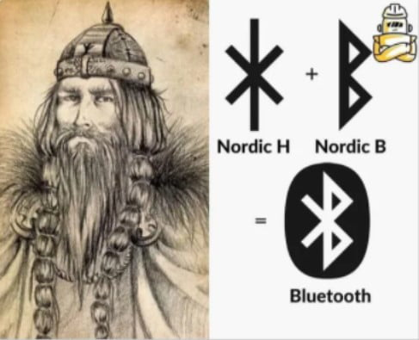*Ericsson Mobile Communications started the development of Bluetooth technology in 1994. The main motive behind the development of this amazing technology was to find an alternative to the use of cables for communication between mobile phones and other devices. In 1998, 4 big companies of that time named Ericsson, IBM, Nokia and Toshiba formed the Bluetooth Special Interest Group (SIG), which published the 1st version of Bluetooth technology in 1999. After that, four versions have been released. The latest version of this technology is Bluetooth 5.0.*

***The Architecture of Bluetooth Technology***

* *In Bluetooth technology, the network of Bluetooth consists of a Personal Area Network or a*
* *Bluetooth's architecture is also called a "****Piconet****" because it is made of multiple networks.*
* *It contains a minimum of 2 to a maximum of 8 Bluetooth peer devices.*
* *It usually contains a single master and up to 7 slaves.*
* *Piconet provides the technology which facilitates data transmission based on its nodes, i.e., Master node and Slave Nodes.*
* *The master node is responsible for sending the data while the slave nodes are used to receive the data.*
* *In Bluetooth technology, data transmission occurs through Ultra-High frequency and short-wavelength radio waves.*
* *The Piconet uses the concept of multiplexing and spread spectrum. It is a combination of code division multiple access (CDMA) and frequency hopping spread spectrum (FHSS) technique.*

***How does Bluetooth work?***

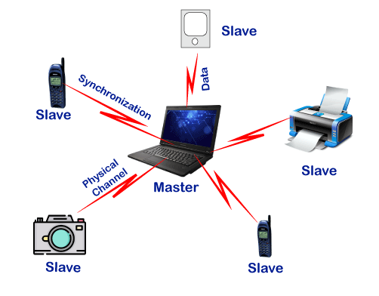*As we stated that there is one master and up to 7 slaves may exist for a Bluetooth connection. The master is the device that initiates communication with other devices. The master device handles the communications link and traffic between itself and the slave devices associated with it. The slave devices have to respond to the master device and synchronize their transmit/receive timing with the master device's specified time.*

*Conditions for Successful Data transmission*

*Following is a list of some conditions that must be satisfied for a successful data transmission in Bluetooth technology:*

* 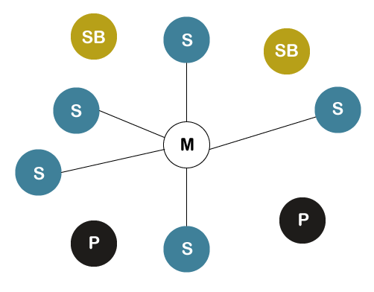*Maximum number of Master Node - 1*
* *Maximum number of Slave Nodes - 7*
* *Maximum number of Nodes in a Piconet - 8*
* *Maximum number of devices that can be paired - 28 - 1 = 255*
* *Number of devices that can be parked → Infinite (∞)*

***Explanation***

* *The parked node is a type of node that is ready to be connected and stand by node is a type of node that can either become a slave or parked node or remains idle or disconnected.*
* *In Bluetooth technology, the data transmission can only occur between master and slave nodes. It cannot be done between slave and slave nodes. However, two master nodes can be connected.*
* *If the connection from the master node gets disconnected, the whole Piconet gets disconnected.*
* *If there is a connection between two master nodes, then that network is called as Scatter-net.*
* *It means scatter-nets are created when a device becomes an active member of more than one Piconet and the adjoining device shares its time slots among the different piconets.*
* *If the number of slaves or devices is increased in a Piconet, then the data transmission speed will be decreased, and if the number of slaves or devices is decreased in number, then the data transmission speed will be increased.*

***Specifications of Bluetooth Technology***

*Bluetooth technology can be specified in two types:*

1. *The Core Specification*
2. *The Protocols Specification*
3. ***The Core Specifications***

*The core specification is used to define the Bluetooth protocol stack and the requirements for the testing and qualification process of the Bluetooth-based products.*

*The core specification of Bluetooth Technology contains 5 layers:*

1. ***Radio****: It is used to specify the requirements for radio transmission such as frequency, modulation, and power characteristics for a Bluetooth transceiver.*
2. ***Baseband Layer****: It is used to define physical and logical channels, voice or data link types, various packet formats, transmit and receive timing, channel control, and the mechanism for frequency hopping and device addressing. It also specifies point to point or point to multipoint links. The length range of a packet can vary from 68 bits to a maximum of* ***3071 bits****.*
3. ***Link Manager Protocol (LMP):*** *The Link manager protocol is used to determine the procedures for link set up and ongoing link management.*
4. ***Logical Link Control and Adaptation Protocol (L2CAP):*** *It is used for adapting upper-layer protocols to the baseband layer.*
5. ***Service Discovery Protocol (SDP):*** *It facilitates the Bluetooth device to query other Bluetooth devices for device information, provided services, and the characteristics of those services.*

*Here, the first three layers denote the Bluetooth module, whereas the last two layers make up the host. The interface between these two logical groups is called the Host Controller Interface.*

1. ***The Protocols Specification***

*It provides usage models to show detailed information about using the Bluetooth protocol for various types of applications.*

***Advantages of Bluetooth Technology***

*Following is a list of some advantages of the Bluetooth technology:*

* *Bluetooth Technology is based on Wireless technology. That's why it is cheap because it doesn't need any transmission wire that reduces the cost.*
* *It is very simple to form a Piconet in Bluetooth technology.*
* *It removes the problem of radio interference by using the Speed Frequency Hopping technique.*
* *The energy or power consumption is very low, about 0.3mW. It makes it possible for the least utilization of battery life.*
* *It is robust because it guarantees security at a bit level. The authentication is controlled using a 128bit key.*
* *You can use it for transferring the data, and verbal communication as Bluetooth can support data channels of up to 3 similar voice channels.*
* *It doesn't require line of sight and one to one communication as used in other modes of wireless communications such as infrared.*

***Disadvantages of Bluetooth Technology***

*Following is a list of some disadvantages of the Bluetooth technology:*

* *In Bluetooth technology, the bandwidth is low.*
* *The data transmission range may also be an issue because it is also less.*

***Applications of Bluetooth Technology***

*Bluetooth technology is used in many communicational and entertainment devices. The following are some most used applications of the Bluetooth technology:*

* *Bluetooth technology is used in cordless desktop. It means the peripheral devices such as a mouse, keyboard, printer, speakers, etc. are connected to the desktop without a wire.*

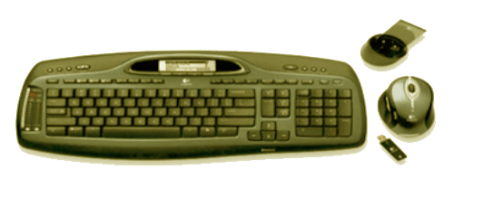

* *It is used in the multimedia transfer, such as exchanging multimedia data like songs, videos, pictures etc. that can be transferred among devices using Bluetooth.*
* *This technology is also used in the following devices: i.e.*
* *Bluetooth Speakers.*
* *Bluetooth Headphones.*
* *Bluetooth Headsets for calling purposes.*
* *Bluetooth gaming consoles etc.*

*1.1.4 Concepts of Wireless Application Protocol (WAP)*

***Wireless Application Protocol (WAP) in Mobile Computing***

*Wireless Application Protocol or WAP is a programming model or an application environment and set of communication protocols based on the concept of the World Wide Web (WWW), and its hierarchical design is very much similar to TCP/IP protocol stack design. See the most prominent features of Wireless Application Protocol or WAP in Mobile Computing:*

*WAP is a De-Facto standard or a protocol designed for micro-browsers, and it enables the mobile devices to interact, exchange and transmit information over the Internet.*

*WAP is based upon the concept of the World Wide Web (WWW), and the backend functioning also remains similar to WWW, but it uses the markup language Wireless Markup Language (WML) to access the WAP services while WWW uses HTML as a markup language. WML is defined as XML 1.0 application.*

*In 1998, some giant IT companies such as Ericson, Motorola, Nokia and Unwired Planet founded the WAP Forum to standardize the various wireless technologies via protocols.*

*After developing the WAP model, it was accepted as a wireless protocol globally capable of working on multiple wireless technologies such as mobile, printers, pagers, etc.*

*In 2002, by the joint efforts of the various members of the WAP Forum, it was merged with various other forums of the industry and formed an alliance known as Open Mobile Alliance (OMA).*

*WAP was opted as a De-Facto standard because of its ability to create web applications for mobile devices.*

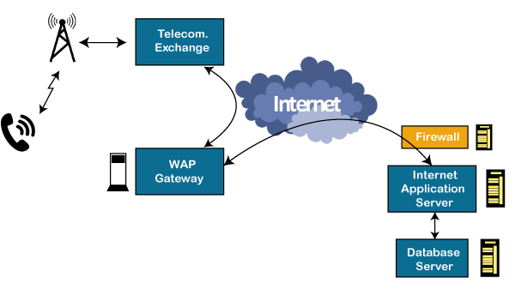

***Working of Wireless Application Protocol or WAP Model***

*The following steps define the working of Wireless Application Protocol or WAP Model:*

* *The WAP model consists of 3 levels known as Client, Gateway and Origin Server.*
* *When a user opens the browser in his/her mobile device and selects a website that he/she wants to view, the mobile device sends the URL encoded request via a network to a WAP gateway using WAP protocol.*
* *The request he/she sends via mobile to WAP gateway is called as encoding request.*
* *The sent encoding request is translated through WAP gateway and then forwarded in the form of a conventional HTTP URL request over the Internet.*
* *When the request reaches a specified Web server, the server processes the request just as it would handle any other request and sends the response back to the mobile device through WAP gateway.*
* *Now, the WML file's final response can be seen in the browser of the mobile users.*

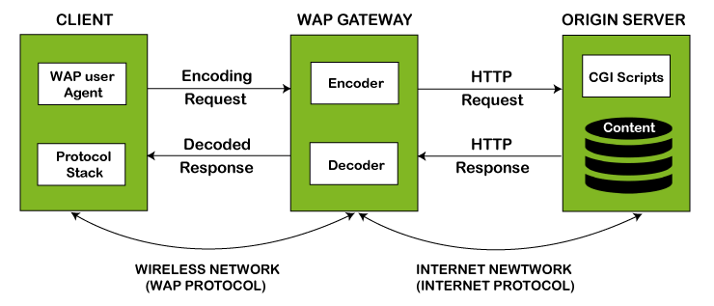

***WAP Protocol Stack***

*It specifies the different communications and data transmission layers used in the WAP model:*

1. ***Application Layer****: This layer consists of the Wireless Application Environment (WAE), mobile device specifications, and content development programming languages, i.e., WML.*
2. ***Session Layer****: The session layer consists of the Wireless Session Protocol (WSP). It is responsible for fast connection suspension and reconnection.*
3. ***Transaction Layer****: The transaction layer consists of Wireless Transaction Protocol (WTP) and runs on top of UDP (User Datagram Protocol). This layer is a part of TCP/IP and offers transaction support.*
4. ***Security Layer****: It contains Wireless Transaction Layer Security (WTLS) and responsible for data integrity, privacy and authentication during data transmission.*
5. ***Transport Layer****: This layer consists of Wireless Datagram Protocol (WDP). It provides a consistent data format to higher layers of the WAP protocol stack.*

***Advantages of Wireless Application Protocol (WAP)***

*Following is a list of some advantages of Wireless Application Protocol or WAP:*

* *WAP is a very fast-paced technology.*
* *It is an open-source technology and completely free of cost.*
* *It can be implemented on multiple platforms.*
* *It is independent of network standards.*
* *It provides higher controlling options.*
* *It is implemented near to Internet model.*
* *By using WAP, you can send/receive real-time data.*
* *Nowadays, most modern mobile phones and devices support WAP.*

***Disadvantages of Wireless Application Protocol (WAP)***

*Following is a list of some disadvantages of Wireless Application Protocol or WAP:*

* *The connection speed in WAP is slow, and there is limited availability also.*
* *In some areas, the ability to connect to the Internet is very sparse, and in some other areas, Internet access is entirely unavailable.*
* *It is less secured.*
* *WAP provides a small User interface (UI).*

***Applications of Wireless Application Protocol (WAP)***

*The following are some most used applications of Wireless Application Protocol or WAP:*

* *WAP facilitates you to access the Internet from your mobile devices.*
* *You can play games on mobile devices over wireless devices.*
* *It facilitates you to access E-mails over the mobile Internet.*
* *Online mobile banking is very popular nowadays.*
* *It can also be used in multiple Internet-based services such as geographical location, Weather forecasting, Flight information, Movie & cinema information, Traffic updates etc. All are possible due to WAP technology.*

*1.1.5 Concepts of Mobile Agents.*

***Mobile Agents in Mobile Computing***

*In Mobile Computing, Mobile Agents are the composition of computer software and data that can autonomously move from one computer to another computer and continue its execution on the destination computer.*

*In other words, you can say that An Mobile Agent is an autonomous program that is capable of moving from host to host in a network and interact with resources and other agents. In this process, the chance of data loss is scarce because the state of the running program is saved and then transported to the new host. It allows the program to continue execution from where it left off before migration. The most significant advantage of mobile agents is the possibility of moving complex processing functions to the location where you have enormous amounts of data and that have to be processed.*

*Mobile Agents are also called as transportable agents. They are classified into two types:*

* *Mobile Agents with pre-defined path: They have a static migration path.*
* *Mobile Agents with undefined path i.e., Roamer: They have dynamic migration paths. The mobile agents choose their path according to the present network condition.*

***Features of Mobile Agents***

*The mobile agents are autonomous with intelligence, social ability, learning, and the most important feature is their mobility. They are independent in nature, self-driven and do not require a corresponding node for communication. They can work efficiently even after the user gets disconnected from the network.*

***Intelligence***

*Mobile Agents are capable of learning and searching for knowledge about their domain. That's why they are called intelligent agents because they possess a degree of domain knowledge. They can also transport their state from one environment to another without disturbing the previous holding data and be capable of performing appropriately in the new environment.*

***Autonomous***

*The Mobile Agents are Autonomous. It means the agents are not only motivated by the outside actions initiated by the users or system but also they have internal events that decided their performance and behavior. The mobile agents can also take an autonomous decision while selecting a node.*

***Mobility***

*Mobile Agents contain some degree of mobility. The agent is not limited to its home node only. They can migrate from one node to another and can carry out tasks along with them. This feature distributes the processing and balancing of the load. Another benefit of this capability is that when the user goes offline, the agents will still keep functioning.*

***Communicative***

*Mobile Agents can communicate effectively with other agents, users and systems. The mobile agents use a communication language for inter-agent communication.*

***Life Cycle of Mobile Agents***

*The life cycle of mobile agents ensures the following conditions:*

* *They can adapt to the environment. For example, either home or foreign environment.*
* *They are capable of switching among the positions of one node to another.*
* *They are autonomous and focused on the final output.*

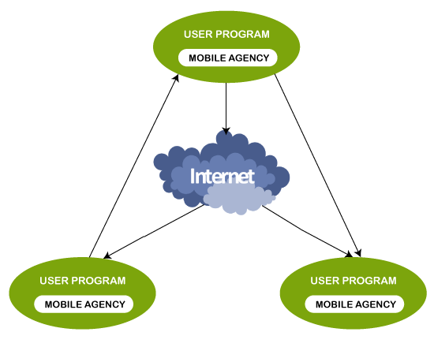

***Advantages of Mobile Agents***

*The following are some advantages of mobile agents over conventional agents:*

* *Mobile Agents are autonomous and self-driven in nature.*
* *They are maintenance-friendly or easily maintainable.*
* *They are Fault-tolerant. It means they are able to operate without an active connection between client and server.*
* *They reduce the compilation time.*
* *They provide less delay in the network.*
* *They provide fewer loads on the network.*
* *They facilitate parallel processing. It means they can be asynchronously executed on multiple heterogeneous network hosts.*
* *They provide dynamic adaptation in which their actions are dependent on the state of the host environment.*

***Disadvantages of Mobile Agents***

*The following are some disadvantages of mobile agents:*

* *The most significant disadvantage of mobile agents is their security. They are less secured*

***Applications of Mobile Agents***

*Mobile agents are used in the following applications:*

* *Mobile Agents are applied in a wide range of domains such as E-commerce, traffic control, network management, robotics, data-intensive applications etc.*
* *They are also used in grid computing, parallel computing, distributed computing and mobile computing etc.*

*1.2 Introduction of Android*

***1.2.1 History, concepts and Features of Android***

*Android tutorial or Android Studio tutorial covers basic and advanced concepts of android technology. Our Android development tutorial is developed for beginners and professionals.*

*Android is a complete set of software for mobile devices such as tablet computers, notebooks, smartphones, electronic book readers, set-top boxes etc.*

*It contains a linux-based Operating System, middleware and key mobile applications.*

*It can be thought of as a mobile operating system. But it is not limited to mobile only. It is currently used in various devices such as mobiles, tablets, televisions etc.*

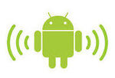***What is Android?***

*Before learning all topics of android, it is required to know what is android.*

*Android is a software package and linux based operating system for mobile devices such as tablet computers and smartphones.*

*It is developed by Google and later the OHA (Open Handset Alliance). Java language is mainly used to write the android code even though other languages can be used.*

*The goal of android project is to create a successful real-world product that improves the mobile experience for end users.*

*There are many code names of android such as Lollipop, Kitkat, Jelly Bean, Ice cream Sandwich, Froyo, Ecliar, Donut etc which is covered in next page.*

***What is Open Handset Alliance (OHA)***

*It's a consortium of 84 companies such as google, samsung, AKM, synaptics, KDDI, Garmin, Teleca, Ebay, Intel etc.*

*It was established on 5th November, 2007, led by Google. It is committed to advance open standards, provide services and deploy handsets using the Android Plateform.*

***Features of Android***

*After learning what is android, let's see the features of android. The important features of android are given below:*

*1) It is open-source.*

*2) Anyone can customize the Android Platform.*

*3) There are a lot of mobile applications that can be chosen by the consumer.*

*4) It provides many interesting features like weather details, opening screen, live RSS (Really Simple Syndication) feeds etc.*

*It provides support for messaging services(SMS and MMS), web browser, storage (SQLite), connectivity (GSM, CDMA, Blue Tooth, Wi-Fi etc.), media, handset layout etc.*

***Categories of Android applications***

*There are many android applications in the market. The top categories are:*

* *Entertainment*
* *Tools*
* *Communication*
* *Productivity*
* *Personalization*
* *Music and Audio*
* *Social*
* *Media and Video*
* *Travel and Local etc.*

***History of Android***

*The history and versions of android are interesting to know. The code names of android ranges from A to J currently, such as Aestro, Blender, Cupcake, Donut, Eclair, Froyo, Gingerbread, Honeycomb, Ice Cream Sandwitch, Jelly Bean, KitKat and Lollipop. Let's understand the android history in a sequence.*

*1) Initially, Andy Rubin founded Android Incorporation in Palo Alto, California, United States in October, 2003.*

*2) In 17th August 2005, Google acquired android Incorporation. Since then, it is in the subsidiary of Google Incorporation.*

*3) The key employees of Android Incorporation are Andy Rubin, Rich Miner, Chris White and Nick Sears.*

*4) Originally intended for camera but shifted to smart phones later because of low market for camera only.*

*5) Android is the nick name of Andy Rubin given by coworkers because of his love to robots.*

*6) In 2007, Google announces the development of android OS.*

*7) In 2008, HTC launched the first android mobile.*

*1.2.2 Concepts of API framework*

***Android Versions, Codename and API***

*Let's see the android versions, codenames and API Level provided by Google.*

|  |  |  |  |
| --- | --- | --- | --- |
| **Code name** | **Version numbers** | **API level** | **Release date** |
| No codename | 1.0 | 1 | September 23, 2008 |
| No codename | 1.1 | 2 | February 9, 2009 |
| Cupcake | 1.5 | 3 | April 27, 2009 |
| Donut | 1.6 | 4 | September 15, 2009 |
| Eclair | 2.0 - 2.1 | 5 - 7 | October 26, 2009 |
| Froyo | 2.2 - 2.2.3 | 8 | May 20, 2010 |
| Gingerbread | 2.3 - 2.3.7 | 9 - 10 | December 6, 2010 |
| Honeycomb | 3.0 - 3.2.6 | 11 - 13 | February 22, 2011 |
| Ice Cream Sandwich | 4.0 - 4.0.4 | 14 - 15 | October 18, 2011 |
| Jelly Bean | 4.1 - 4.3.1 | 16 - 18 | July 9, 2012 |
| KitKat | 4.4 - 4.4.4 | 19 - 20 | October 31, 2013 |
| Lollipop | 5.0 - 5.1.1 | 21- 22 | November 12, 2014 |
| Marshmallow | 6.0 - 6.0.1 | 23 | October 5, 2015 |
| Nougat | 7.0 | 24 | August 22, 2016 |
| Nougat | 7.1.0 - 7.1.2 | 25 | October 4, 2016 |
| Oreo | 8.0 | 26 | August 21, 2017 |
| Oreo | 8.1 | 27 | December 5, 2017 |
| Pie | 9.0 | 28 | August 6, 2018 |
| Android 10 | 10.0 | 29 | September 3, 2019 |
| Android 11 | 11 | 30 | September 8, 2020 |
| Android 12 | 12 | 31 | February 18, 2021 |

*1.3 Intro. of Android Architecture (Software Stack)*

*1.3.1 kernel Native Libraries*

*1.3.2 Concepts of Native Libraries and Android Runtime (Dalvik VM)*

*1.3.3 Application Framework*

*1.3.4 Application*

***Android Architecture***

*android architecture or Android software stack is categorized into five parts:*

1. *linux kernel*
2. *native libraries (middleware),*
3. *Android Runtime*
4. *Application Framework*
5. *Applications*

*Let's see the android architecture first.*

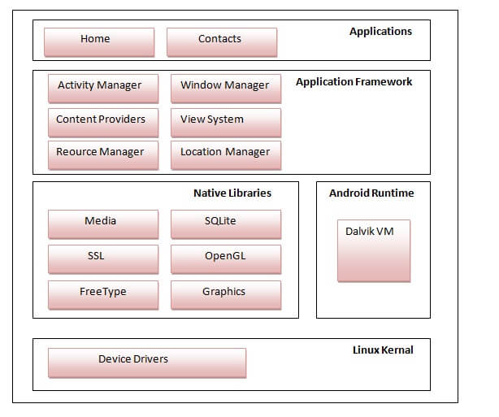

*1) Linux kernel*

*It is the heart of android architecture that exists at the root of android architecture. Linux kernel is responsible for device drivers, power management, memory management, device management and resource access.*

*2) Native Libraries*

*On the top of linux kernel, their are Native libraries such as WebKit, OpenGL, FreeType, SQLite, Media, C runtime library (libc) etc.*

*The WebKit library is responsible for browser support, SQLite is for database, FreeType for font support, Media for playing and recording audio and video formats.*

*3) Android Runtime*

*In android runtime, there are core libraries and DVM (Dalvik Virtual Machine) which is responsible to run android application. DVM is like JVM but it is optimized for mobile devices. It consumes less memory and provides fast performance.*

*4) Android Framework*

*On the top of Native libraries and android runtime, there is android framework. Android framework includes Android API's such as UI (User Interface), telephony, resources, locations, Content Providers (data) and package managers. It provides a lot of classes and interfaces for android application development.*

*5) Applications*

*On the top of android framework, there are applications. All applications such as home, contact, settings, games, browsers are using android framework that uses android runtime and libraries. Android runtime and native libraries are using linux kernel*

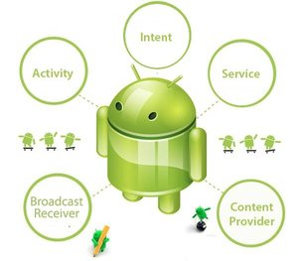***Android Core Building Blocks***

***Android Components***

*An android component is simply a piece of code that has a well defined life cycle e.g. Activity, Receiver, Service etc.*

*The core building blocks or fundamental components of android are activities, views, intents, services, content providers, fragments and AndroidManifest.xml.*

***Activity***

*An activity is a class that represents a single screen. It is like a Frame in AWT.*

***View***

*A view is the UI element such as button, label, text field etc. Anything that you see is a view.*

***Intent***

*Intent is used to invoke components. It is mainly used to:*

* *Start the service*
* *Launch an activity*
* *Display a web page*
* *Display a list of contacts*
* *Broadcast a message*
* *Dial a phone call etc.*

*For example, you may write the following code to view the webpage.*

*Intent intent=new Intent(Intent.ACTION_VIEW);*

*intent.setData(Uri.parse("http://www.nehalpatel.in"));*

*startActivity(intent);*

***Service***

*Service is a background process that can run for a long time.*

*There are two types of services local and remote. Local service is accessed from within the application whereas remote service is accessed remotely from other applications running on the same device.*

***Content Provider***

*Content Providers are used to share data between the applications.*

***Fragment***

*Fragments are like parts of activity. An activity can display one or more fragments on the screen at the same time.*

***AndroidManifest.xml***

*It contains informations about activities, content providers, permissions etc. It is like the web.xml file in Java EE.*

***Android Virtual Device (AVD)***

*It is used to test the android application without the need for mobile or tablet etc. It can be created in different configurations to emulate different types of real devices.*